|  |  |  |
| --- | --- | --- |
|  | **Project Design Phase-II** | |
|  | **Technology Stack (Architecture & Stack)** | |
|  |  |  |
| Date |  | 09 October 2022 |
| Team ID |  | PNT2022TMID31240 |
| Project Name |  | Project – Natural disaster intensity analysis and |
|  |  | classification using artificial intelligence |
| Maximum Marks |  | 4 Marks |

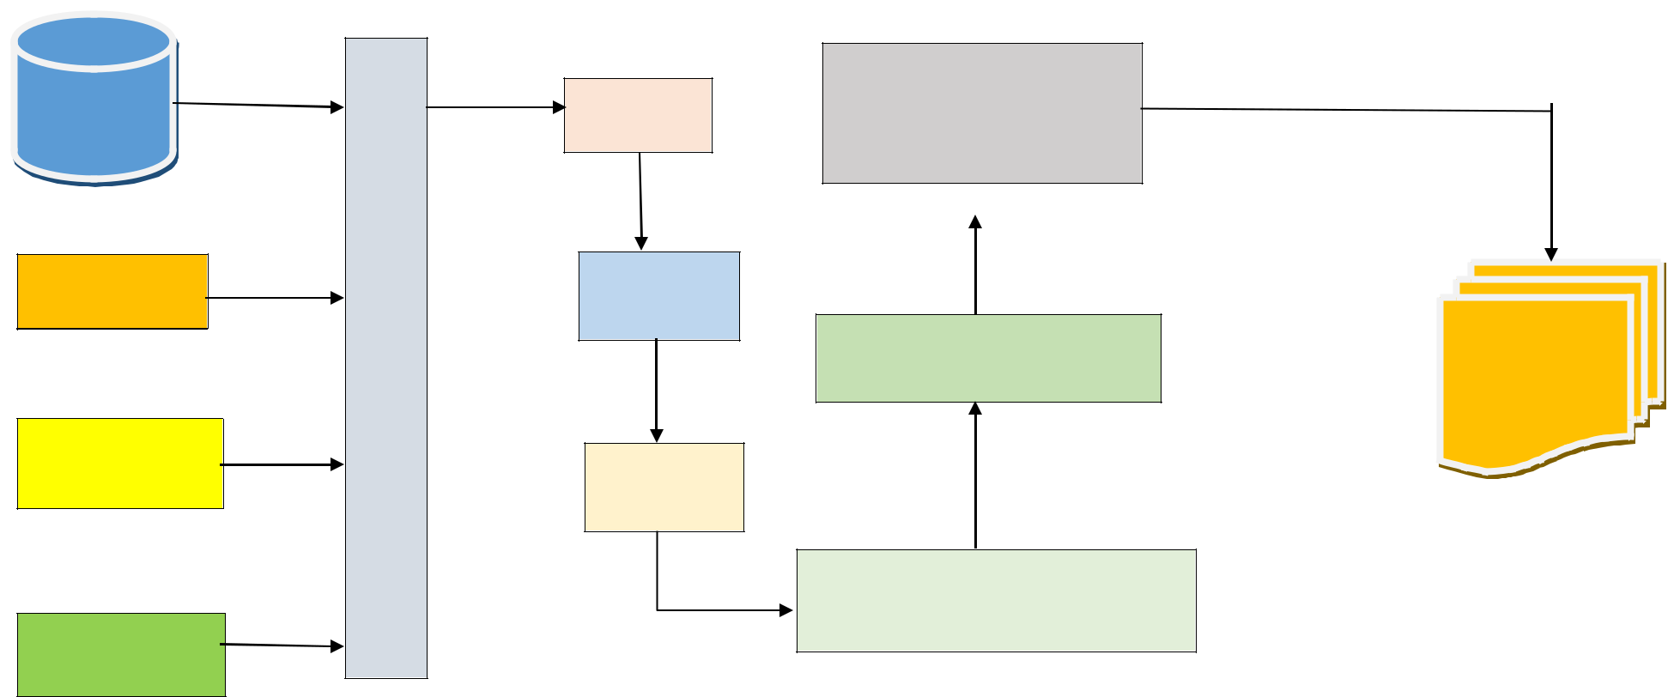

Real time

data

Sensors

Radars

Satellite images

|  |  |  |
| --- | --- | --- |
| **D** | Prediction |  |
|  |  |
| **A** |  |  |
| **T** |  |  |
| **A** |  |  |
|  | Model |  |

|  |  |  |
| --- | --- | --- |
| **P** |  |  |
| **R** |  |  |
| **O** |  |  |
| **C** |  |  |
| **E** | Evaluation |  |
| **S** |  |
| **S** |  |  |
| **I** |  |  |
| **N** |  |  |
| **G** |  |  |

Prediction on latest model

Deploy models

Deep learning algorithm

Image data

**Table-1 : Components & Technologies:**

|  |  |  |
| --- | --- | --- |
| **SI.No** | **Component** | **Description** |
|  |  |  |
| 1. | Real time data | The data from various events are collected |
|  |  |  |
| 2. | Sensors | Data from sensors during the time of |
|  |  | disaster are also collected |
| 3. | Radars | Signals from the radars are collected |
|  |  |  |
| 4. | Data processing | Data from various sources are processed |
|  |  | using some algorithm |
| 5. | Model | Using machine learning algorithms the |
|  |  | model is predicted . |
| 6. | Evaluation | The obtained model is trained and tested |
|  |  |  |
| 7. | Deploy models | The model is put into process |
|  |  |  |
| 8. | Prediction on latest model | The newly obtained model is analysed |
|  |  |  |
| 9. | Image | At last the image is obtained which can |
|  |  | predict the intensity of disasters in future |
|  |  |  |